Simulation Study on Dynamics of Wealth Differentiation

based on Initial Population and Resource Endowment

1 Aim

The Sugarscape model alters agents’ behaviour rules to simulate individuals searching for and consuming resources within a ‘CompuTerrarium’ to survive and reproduce (Epstein and Axtell, 1997). Compared to ‘Sugarscape 2 Constant Growback’, ‘Model 3 Wealth Distribution’ introduces an ageing-death parameter to present the finite lifespan of the agent which reflects the natural population renewal mechanism. This prevents the population size and structure from being permanently solidified, but maintains a dynamic balance to represent the wealth distribution of reality entities.

* Aim 1: Examine how different combinations of initial population size and resource endowment distribution affect the survival rates of agents over time.
* Aim 2: Observe the emergence and dynamics of wealth stratification by wealth inequality metrics under varying initial conditions.

2 Method

2.1 Model Docking

To systematically investigate the influence of different initial conditions, the study made alignment in Sugarscape2 to replicate the wealth distribution result by adding the same wealth inequality metrics in model 3 such as Gini-index and Lorenz curve (Axtell *et al.*, 1996). The modified code is attached in appendix.

2.2 Population Base Experiment

Different population bases in model will lead to varied resource acquisition strategies, so the research added survival rate in Sugarscape2, calculating the ratio between survivors and initial setting population to reflect the intensity of resource competition among agents. Compared with the survival ratio in model2, Sugarscape3 introduced death rate of agents by splitting the death count due to starvation and ageing. In that case, the death ratio showed the percentage of starvation deaths among other reasons, which clarified the impact of resource scarcity and other physiological conditions on agent survival.

The first experiment explored population sizes ranging from 0 to 1000, with increments of 20. For each unique population size, maximum (25) and minimum (5) resource endowment and other parameters remained in default values, ensuring both shared the same pattern. The model was run 5 times for a fixed number of time steps (1000 ticks) in the Behaviour Space of NetLogo.

2.3 Resource Allocation Experiment

Wealth disparity reflects the level of inequality in wealth distribution among agents. To observe the changing trend of the agents’ Gini index and death rate under different initial wealth gaps, the experiment set the maximum sugar endowment from 20 to 50, and the minimum resources from 0 to 30, both with an interval of 5. The initial population size was set to the mean value (500) of the first experiment.

2.4 Combined Experiment

The combined experiment conducted different combinations of the same range in initial population bases and resource distribution. It investigated the survival/death ratio and final wealth distribution over time, especially after introducing the ageing mechanism to reflect realistic phenomena.

3 Result

3.1 Population Base Experiment

The mean sugar amount decreases as the initial population size increases. This suggests that with more agents competing for resources, the average resource availability per agent diminishes. Additionally, the disparity in sugar availability between individuals becomes less pronounced and more uniform across the population, as evidenced by the low p-value. Although the average resource level decreases, the simulation finds that the Gini coefficient decreases and resource distribution becomes more equal. This may be because under high population pressure, individual has relatively equal access to resources, leading to distribution convergence. In reality, during periods of resource scarcity, the overall level of poverty may generally increase, but the degree of inequality in income distribution may not worsen.

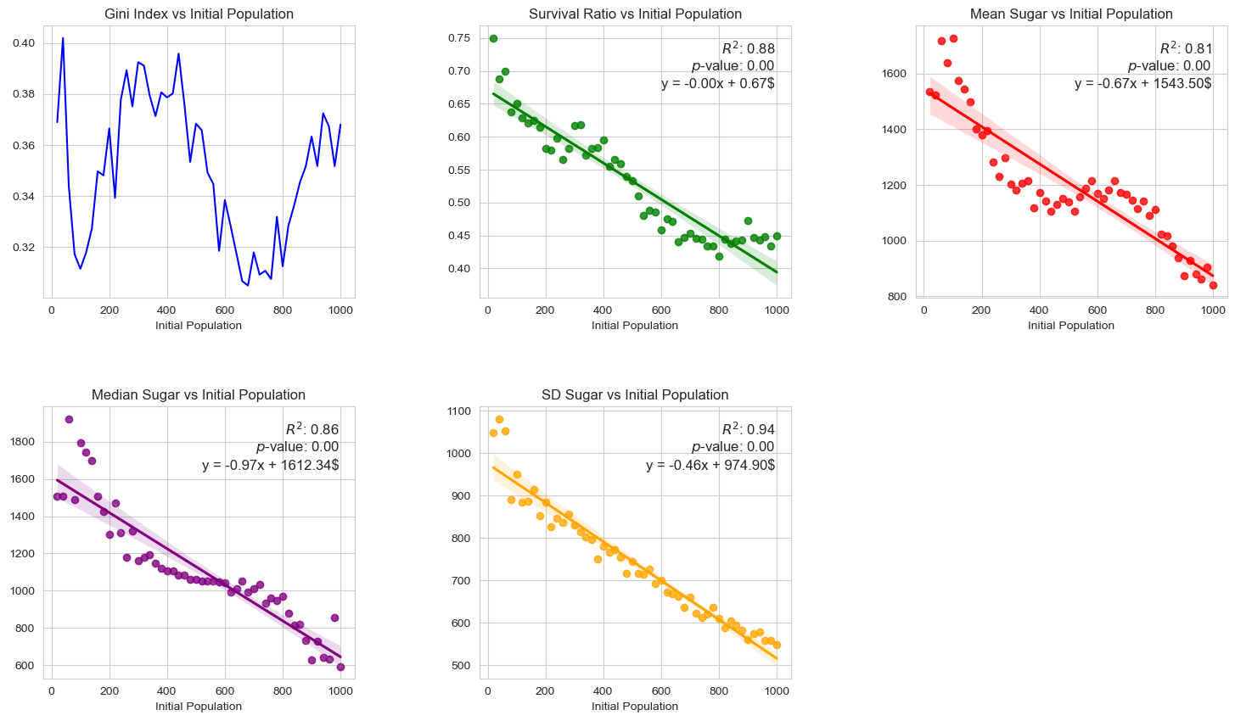

1. Population base experiment (Sugarscape2 )

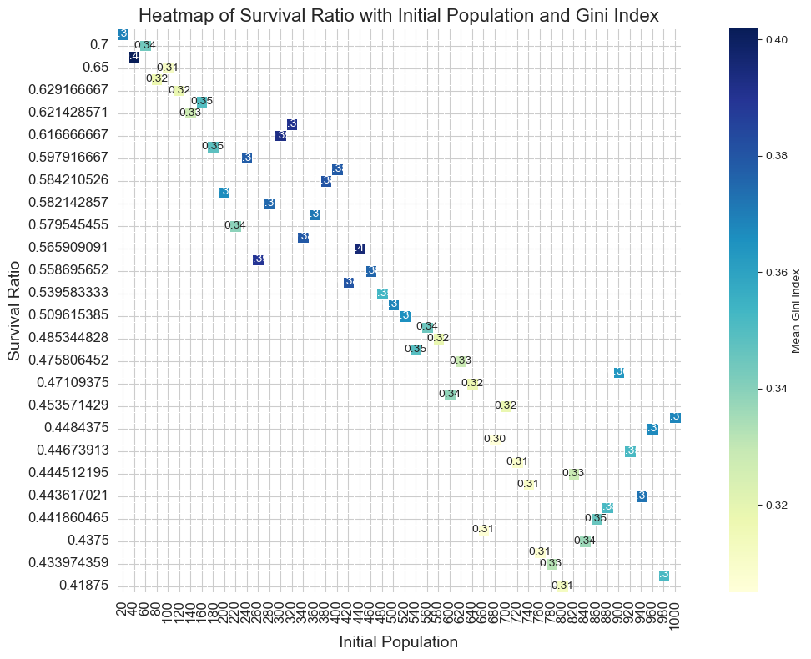

1. Heatmap of survival ratio with initial population and Gini index (Sugarscape2 )

The simulation shows that the survival rate decreases as the population increases, indicating that the environment has a certain upper limit of population capacity. This is in line with the Malthusian population theory. Without considering the aging mechanism, a population of around 100 appears to be optimal for wealth equality in society, while still maintaining a relatively high survival rate. When the population exceeds the environmental capacity, various problems will occur that endanger survival so that finding the right population size to maintain sustainable development is a real challenge.

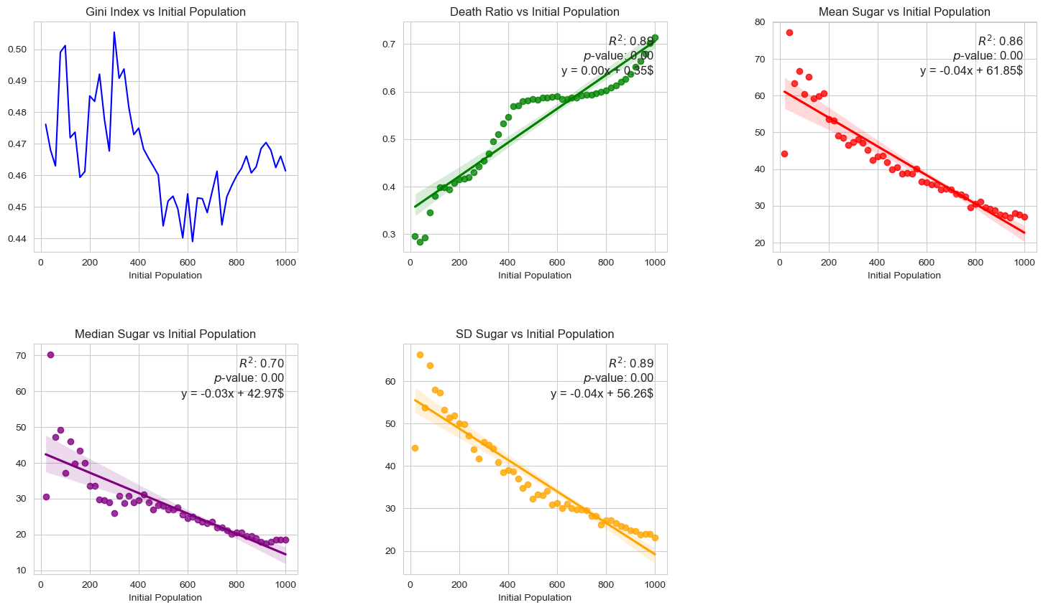

1. Population base experiment (Sugarscape3 )

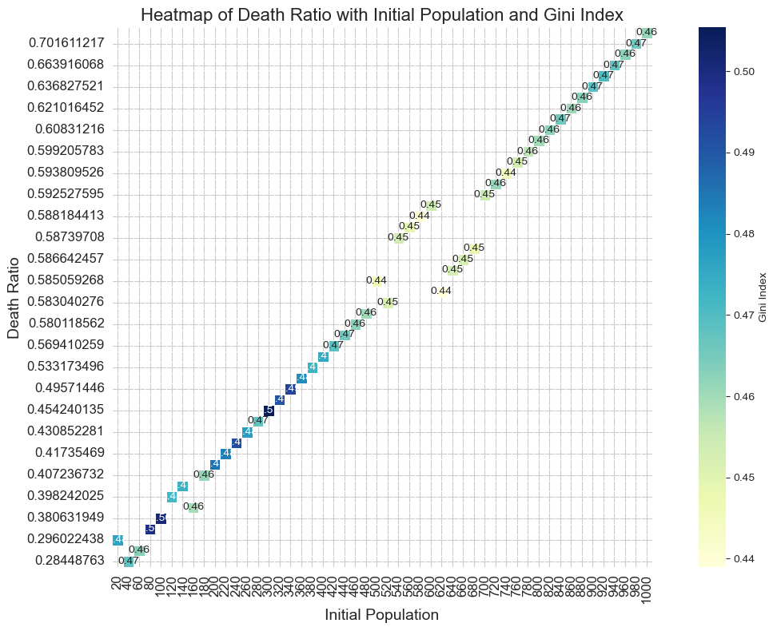

1. Heatmap of survival ratio with initial population and Gini index (Sugarscape3 )

3.2 Resource Allocation Experiment

As can be seen from the figure, as the minimum resource allocation increases, the Gini coefficient appears to increase at some maximum resource allocation levels. This may suggest that, in the absence of aging death and rebirth, raising the minimum resource allocation may lead to an increase in overall inequality, especially when the maximum resource allocation is relatively high.

In Figure (b), after adding the mechanisms of aging, death and rebirth, the overall trend of the Gini coefficient seems to be different. At some levels of maximum resource allocation, an increase in minimum resource allocation leads to a decrease in the Gini coefficient, especially in areas with lower minimum resource allocation. This suggests that mechanisms of aging and regeneration may help mitigate inequality in resource distribution.

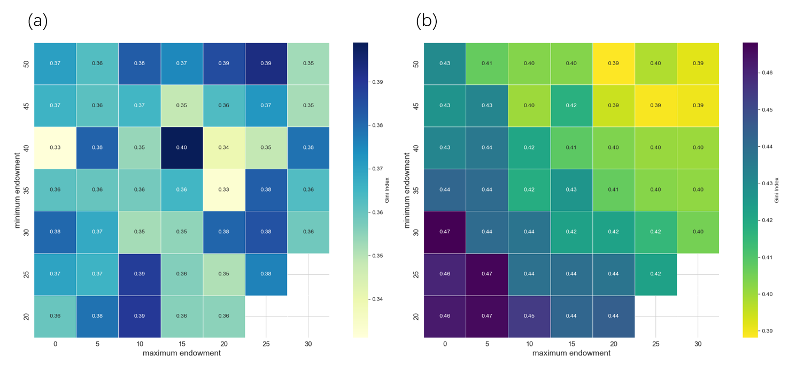The 3D surface plots (Fig.5) depicted the relationship between the Gini index, survival/death ratio and the initial minimum and maximum sugar endowments.

Peak survival occurs at mid-level minimum sugar endowment (10-20) and high maximum sugar endowment (35-45). This means moderate starting resource differences and ensuring that most agents have sufficient initial resources, which is beneficial to improving overall survival rate. When the minimum sugar endowment is very low (close to 0), survival rates drop sharply regardless of the maximum endowment. If some agents are in a state of extreme poverty from the beginning, it will seriously threaten the survival of the entire group.

In addition, when the gap between the min and max endowments is small, the survival rate is also low. This may be because excessive equality will reduce the motivation and resource competition among agents, affecting survivability.

Moderate initial resource differences help agent groups survive, but extreme poverty and excessive equality both reduce survival rates. Maintaining a certain degree of wealth disparity while ensuring a basic standard of living may be the best way to improve survival ability

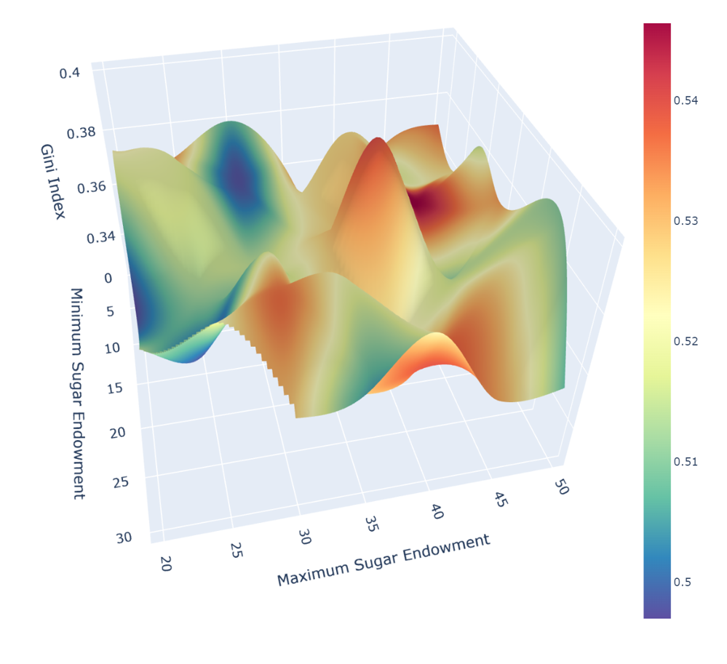

1. 3D plot (Sugarscape2 )

Figure 6 showed how the proportion of agents dying from starvation changes as a function of sugar endowment after introducing aging-death mechanisms. The color range from dark red to dark blue represents the changing trend from high to low proportion of deaths due to starvation.

Starvation mortality reaches its highest value when the minimum sugar endowment is very low (close to 0) and the maximum endowment level is moderate to high. It indicated if some agents are in a state of extreme poverty from the beginning, they are likely to be unable to obtain enough resources and eventually starve to death.

Starvation mortality is lowest when the minimum sugar endowment remains at a certain level (about 15 and above), which meant hunger problems can be minimized by ensuring that all agents have basic starting resources and avoiding excessive wealth disparity. When the gap between the minimum and maximum endowments is small, starvation mortality also increases. This may be because excessive equality will reduce the competitive motivation among agents and affect the ability to obtain resources.

When the minimum endowment is maintained at a certain level, moderately increasing the maximum endowment value can reduce starvation mortality (lighter color). This shows that a moderate resource gap can stimulate healthy competition among agents and improve overall survivability.

From a practical point of view, these findings reveal that ensuring basic living standards, avoiding extreme poverty, and maintaining a moderate income gap may be the best policy combination to reduce hunger and improve the quality of life.

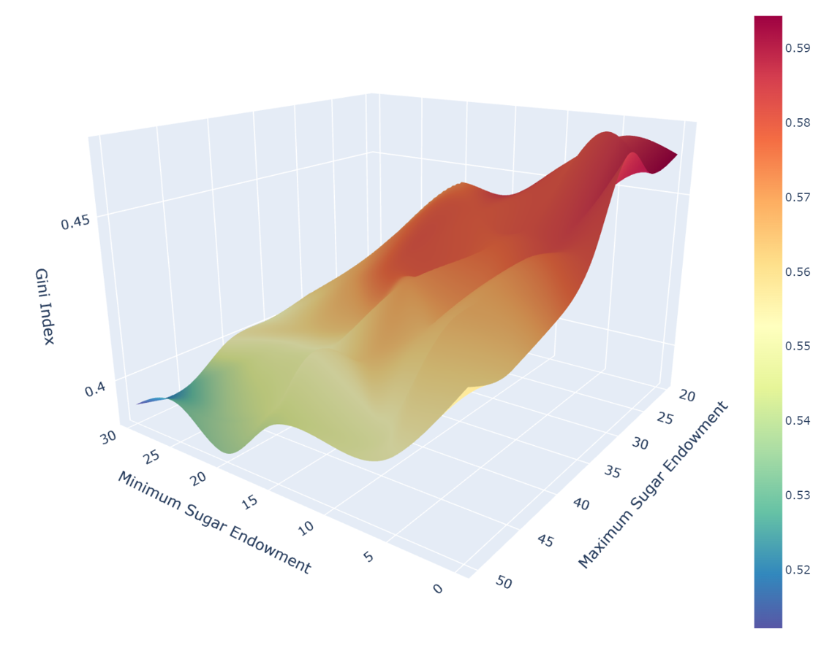

1. 3D plot (Sugarscape3 )

3.3 Combined Experiment

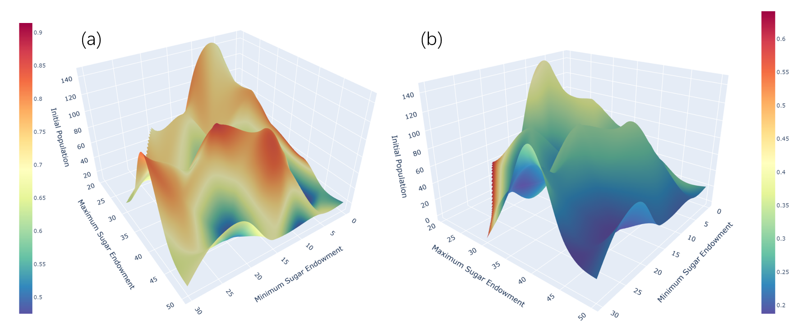

1. Survival/death ratio under different initial conditions

(a) Sugarscape2 (b) Sugarscape3

These two 3D surface plots illustrate how the Gini coefficient changes as the initial population size and starting resource endowment change.

(a) The aging, death and rebirth mechanism is not considered:

The Gini coefficient peak area is concentrated in parameter combinations with low initial population, low minimum endowment, but high maximum endowment.

This shows that under such extremely unequal initial resource distribution, the gap between rich and poor will intensify.

When the minimum endowment increases or the population increases, the Gini coefficient will gradually decrease, indicating that the gap between rich and poor decreases.

Moderate population size and resource differences help maintain a relatively balanced distribution state (the area with the lowest Gini coefficient).

(b) After introducing the aging, death and rebirth mechanism:

Overall, the Gini coefficient values are generally high, and the polarization between rich and poor has intensified.

The peak area is offset from (a), with the highest point occurring at moderate combinations of population and resource endowment.

When the minimum endowment is extremely low or the population is too large, the Gini coefficient decreases, but overall it remains at a high level.

The surface shape is smoother and the fluctuations are smaller, indicating that after the dynamic population mechanism is introduced, the trend of wealth differentiation is more stable.

Comparing (a) and (b), it is found that introducing the aging, death and rebirth mechanism will intensify the overall wealth gap, but it also reduces the degree of wealth differentiation under extreme parameter combinations, making the results more concentrated. This may be due to the fact that agents continue to die and be replaced by new agents, causing a redistribution and balancing effect of rich and poor.

From a practical perspective, these findings suggest:

A moderate population size and a reasonable initial resource gap help maintain a relatively fair state of society.

However, the natural cycle of birth, aging, illness and death of the population may also exacerbate the polarization between rich and poor, which requires policy intervention to regulate.

Ensuring that all citizens have access to basic survival resources and avoiding extreme poverty is a key priority.

At the same time, appropriate income gap incentives must be provided to create a healthy competitive environment and promote the overall development of society.

Overall, these simulation results provide valuable insights into our understanding of the intrinsic links between population, resources, and distribution of wealth and poverty, and are helpful in formulating relevant social policies.

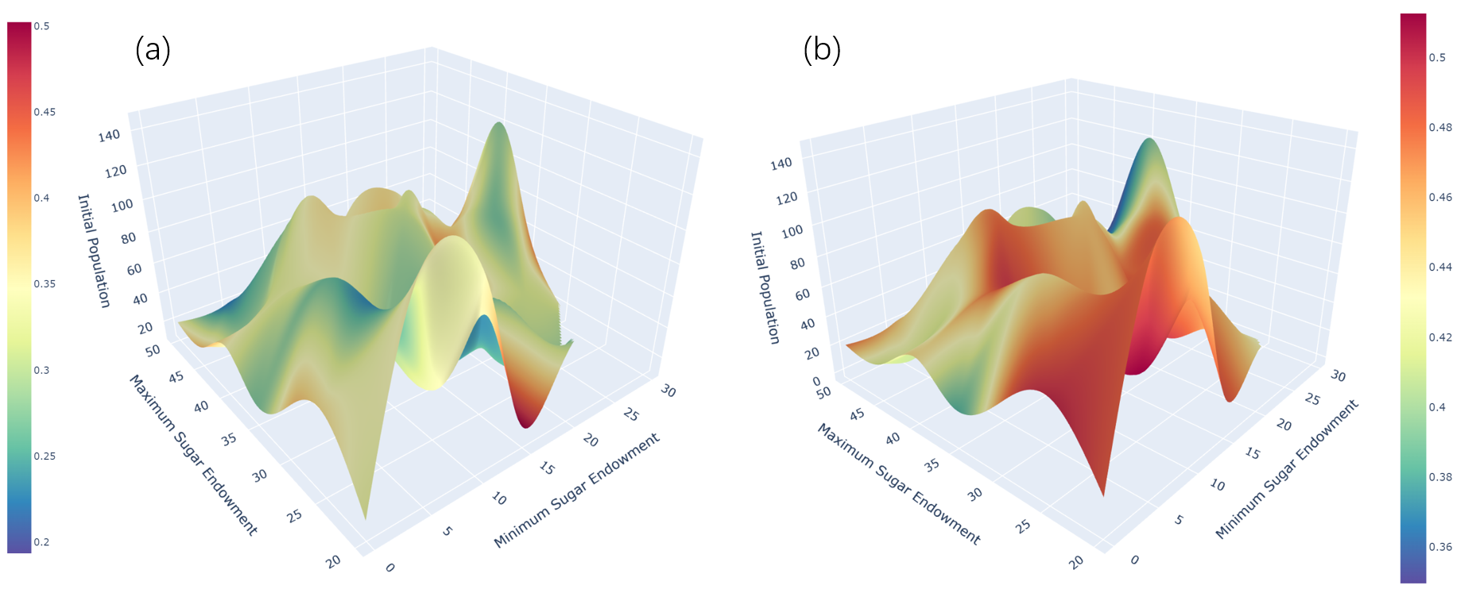

1. Gini index under different initial conditions

(a) Sugarscape2 (b) Sugarscape3

4 Discussion

The simulation results obtained from the Sugarscape model, particularly the variations between Sugarscape 2 (Constant Growback) and Sugarscape 3 (Wealth Distribution with ageing-death parameter), offer profound insights into the dynamics of resource distribution, population sustainability, and wealth inequality in artificial societies. These insights have implications for understanding similar dynamics in real-world societies.

Comparison of Sugarscape 2 and Sugarscape 3 Models

Population Sustainability: Both models demonstrate the Malthusian principle that there exists an environmental carrying capacity beyond which the population cannot be sustained without leading to increased mortality. However, the introduction of an ageing-death parameter in Sugarscape 3 provides a more dynamic balance, mimicking natural population renewal mechanisms. This addition allows the model to more accurately reflect real-world population dynamics, where populations do not grow indefinitely but stabilize or fluctuate within certain bounds due to natural life cycles.

Wealth Distribution and Inequality: The experiments highlight how different initial conditions of population size and resource distribution affect wealth stratification. In Sugarscape 2, without the ageing-death mechanism, wealth distribution tends to become more equal under conditions of high population pressure, as resources are more uniformly distributed due to intense competition. However, this equalization does not necessarily mean an improvement in overall well-being, as it could coincide with a general decrease in resource availability per capita. The introduction of the ageing-death mechanism in Sugarscape 3 alters this dynamic, demonstrating that a moderate degree of wealth disparity, coupled with ensuring basic resources for all, can improve survival rates and reduce the intensity of wealth inequality.

Resource Allocation Strategy: The Resource Allocation Experiment results suggest that a balance needs to be struck between ensuring a minimum standard of living (to avoid deaths from starvation) and maintaining a level of resource disparity (to stimulate competition and efficiency in resource use). Excessive equality as much as extreme poverty can harm the society by reducing the motivation for improvement or by increasing mortality rates, respectively.

Implications for Real-World Societies

The findings from both Sugarscape models offer valuable lessons for real-world social policies:

Population Control and Sustainability: Policies aiming at sustainable development should consider the carrying capacity of the environment and resources. Overpopulation can lead to increased competition for limited resources, reducing overall well-being.

Wealth Distribution: A balanced approach to wealth distribution that avoids extreme poverty while maintaining enough disparity to motivate economic activity and improvement can lead to healthier societies. This balance is crucial in policy formulation, where the aim should be to minimize wealth inequality without discouraging productive competition.

Resource Allocation: Ensuring that all members of society have access to basic necessities is essential for minimizing mortality due to resource scarcity and for maintaining social stability. At the same time, a healthy level of economic inequality can serve as an incentive for innovation and efficiency.

5 Conclusion

The Sugarscape simulations, particularly the contrast between Models 2 and 3, illustrate the complex interplay between population dynamics, resource distribution, and wealth inequality. These models show that achieving a sustainable, equitable society requires a delicate balance between ensuring a minimum standard of living for all and maintaining a level of economic disparity that encourages productive competition. The introduction of an ageing-death mechanism in Model 3 adds a realistic dimension to the simulation, offering deeper insights into how natural life cycles can impact wealth distribution and societal stability. These findings underscore the importance of informed policy-making that considers the multifaceted nature of wealth distribution, resource allocation, and population dynamics.

References

Axtell, R., Axelrod, R., Epstein, J. M. and Cohen, M. D. (1996). ‘Aligning simulation models: A case study and results’. *Computational & Mathematical Organization Theory*, 1 (2), pp. 123–141. doi: 10.1007/BF01299065.

Epstein, J. M. and Axtell, R. (1997). ‘Artificial societies and generative social science’. *Artificial Life and Robotics*, 1 (1), pp. 33–34. doi: 10.1007/BF02471109.

* Aim – *Explain what aspects of the models’ behaviour you intend to investigate.*
* Methods – *Clearly and completely detail the experiments that you performed.*
* Results – *Communicate the results of the experiments through graphs and tables.*
* Discussion – *Interpret your results and compare the different models.*
* Conclusion – *Summarise your main findings, relating back to your aims.*

1. choosing some aspect or aspects of the model behaviour to measure (e.g. final population, average vision, average metabolism, average wealth…) and potentially adding new reporters to the code (to-report … end) to calculate these metrics;
2. choosing which parameters to alter and which values of those parameters to consider.

- Any new reporters added to the code should be added to your report in an appendix.

好的,通过分析模型在不同初始糖分分配范围(代表不同初始贫富差距水平)下的运行结果,我们可以观察到以下几个方面的影响,并得出相应的启示:

1代理存活率

观察代理的最终存活率在不同初始贫富差距下的变化趋势

如果初始贫富差距过大,可能会导致一部分代理一开始就缺乏足够的资源维持生存,从而降低总体存活率

适度的初始贫富差距可能会营造一种"适者生存"的环境,提高代理的竞争力和存活率

2贫富分化程度(基尼系数)

基尼系数反映了代理间最终贫富分化的程度

分析基尼系数在不同初始条件下的变化,可以看出初始贫富差距是否会加剧还是缓解了最终的贫富差距

这有助于探讨贫富差距的机制和影响因素

3不同群体的糖分分布

模型还计算了不同视野/代谢率组的平均、中位数和标准差糖分值

通过分析这些指标,可以观察到不同"群体"在不同初始条件下的糖分分布变化

从而探讨不同群体的竞争力如何受初始条件的影响

4生存和死亡原因

如果模型考虑了寿命和死因统计,还可以分析在不同贫富差距下,代理的主要死亡原因是饥饿还是自然老去

这有助于厘清资源匮乏和其他生理条件对代理生存的影响

通过综合分析上述多个方面的结果,我们可以深入理解初始贫富差距对模型世界的影响机制,从中得出一些有价值的启示,例如:

适度的初始贫富差距可能更利于系统的可持续发展

减少过度的贫富极化有助于提高整体福利水平

制定相应的政策为弱势群体提供适当资源支持至关重要

应重视机会公平,确保不同群体拥有合理的竞争环境

等等

The main aim of this study is to investigate how the initial population size and resource endowment differences influence the evolution of wealth inequality in an agent-based society model. Specifically, we intend to explore the following aspects:

Impact on Agent Survival Rates:

Examine how different combinations of initial population size and resource endowment distribution affect the overall survival rates of agents over time.

Analyze whether extreme initial inequality or overpopulation leads to higher mortality rates due to resource scarcity.

Emergence and Persistence of Wealth Stratification:

Observe the formation and dynamics of wealth classes among the agent population under varying initial conditions.

Assess the extent to which initial resource endowment differences propagate or diminish as the model runs.

Study the evolution of wealth inequality metrics, such as the Gini index and Lorenz curve, across different scenarios.

Resource Acquisition and Allocation Patterns:

Investigate how agents with different initial endowments compete for and acquire resources (sugar) in the environment.

Analyze potential disparities in resource accumulation among agents with varied vision ranges and metabolic rates.

Influence on Population Attributes:

Examine how the initial conditions shape the distribution of agent attributes like vision range, metabolism, and lifespan within the population over time.

Identify potential correlations between agent traits and their ability to acquire and maintain resources under different scenarios.

By systematically varying the initial population size and the range of resource endowment values, we aim to gain insights into the driving forces behind wealth inequality dynamics in artificial societies. The findings from this study could provide valuable implications for understanding and addressing socio-economic disparities in real-world contexts.

A moderate initial wealth gap may be more conducive to the sustainable development of the system

Reducing excessive wealth polarization can help improve overall welfare

It is crucial to develop policies to provide appropriate resource support to vulnerable groups

We should pay attention to fair opportunities and ensure that different groups have a reasonable competitive environment